You will need to start the process of creating custom IP from some existing Vivado project. This project does not need to have any relationship with the custom IP that you are creating in this howTo.
The goal of this step is to create the entity/architecture for the enhancedPwm_ip_v1_0 component shown in the diagram below. Look at Figure 1 and find the enhancedPWM component. Let’s explore where the signal on its entity are being routed to.
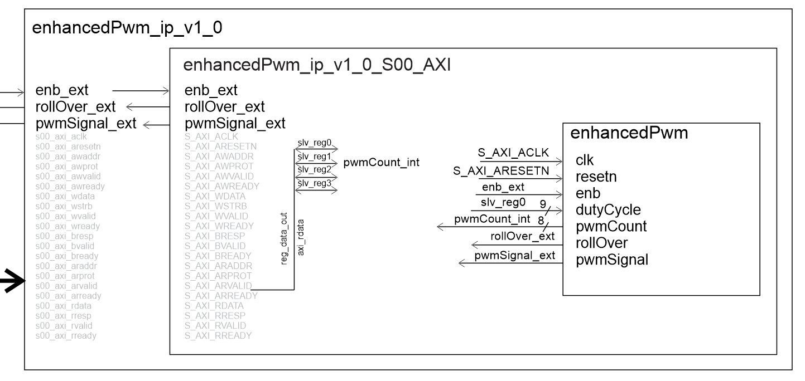
Figure 1: The hierarchy of components needed to interface a custom module to the ARM cortex and the outside world.
The signals on the enhancedPwn interface will come from several different sources:
- clk and reset will come from the S_AXI signals coming in through the enhancedPwm_ip_v1_0_S00_AXI interface.
- enb, pwmSignal and rollOver will go outside the Zynq chip and connect to PL_KEY4, pin 3 on header J11 and the interrupt input on the Zynq respectively.
- dutyCycle and pwmCount will be written/read by a program that we will write for the ARM processor in a later stage.
The grey signal names on the entities in Figure 1 are part of the AXI interface and as such, not your concern – leave them alone. When a signal from your custom IP needs to leave the Zynq chip, you must add that signal to the two “enhancedPwm_ip_v1_0” interfaces.
When a signal from your custom IP needs to interface to the ARM processor, you need to deal with the slv_regX interface.
The following process is very detailed and you can easily make errors. So take your time, mind the details and try to stay focused. Good luck.
Create Custom IP:
Start by selecting Tools => Create and Package New IP….
You will be presented with the Create and Package New IP wizard:
Create Peripheral, Package IP: Click Next
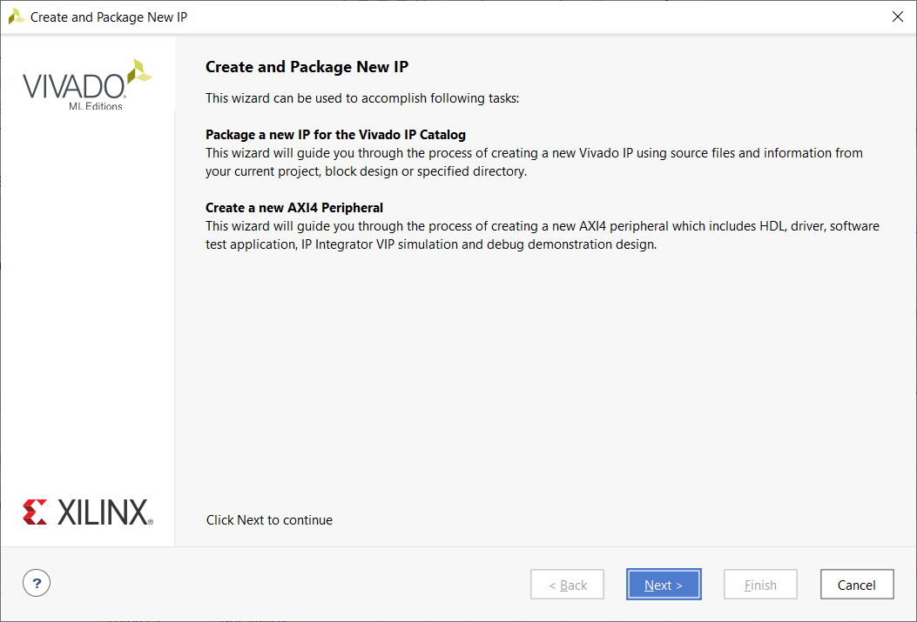
Create Peripheral, Package IP: Select Create AXI4 Peripheral. Click Next.
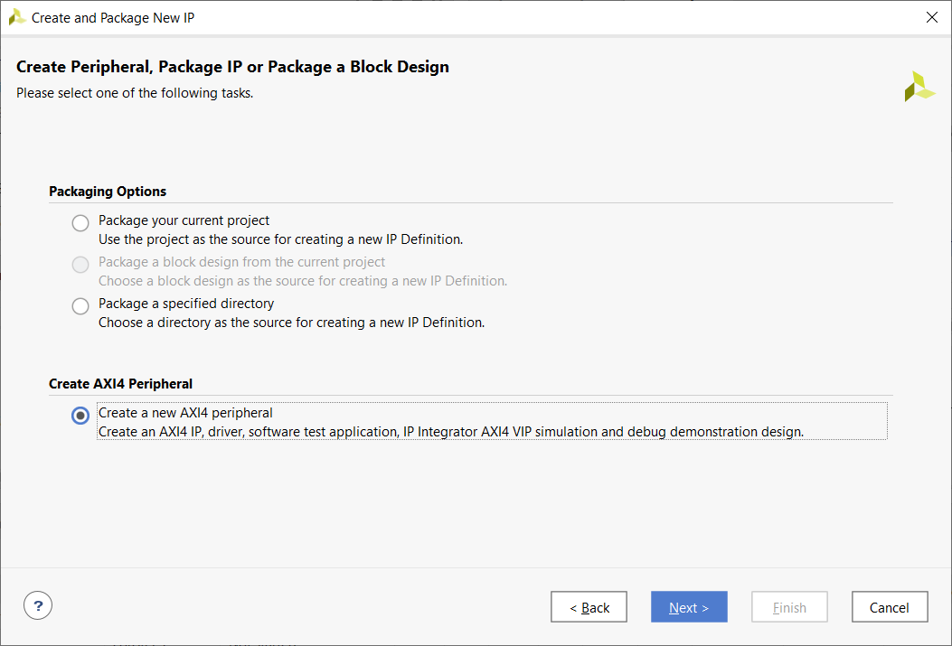
Peripheral Details: Complete name and IP location. Click Next.
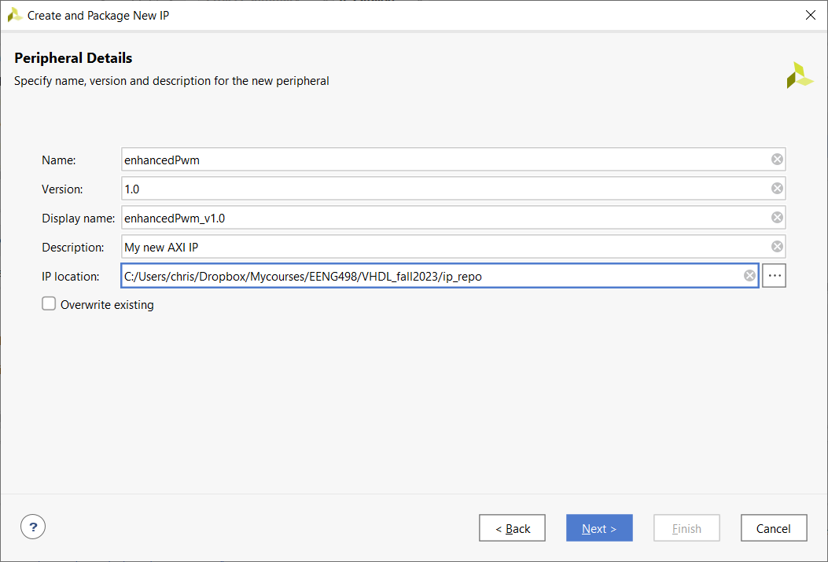

Add Interfaces: Select 4 registers, leave all the other defaults alone. Click Next.
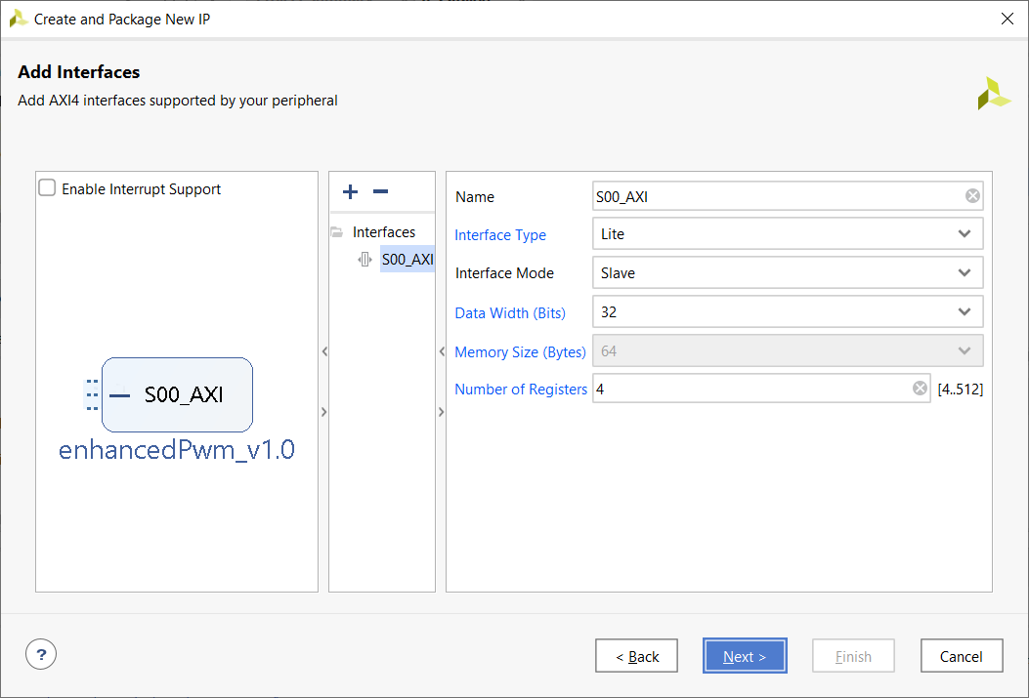
Create Peripheral: Select the Add IP to repository radio button. Click Finish.
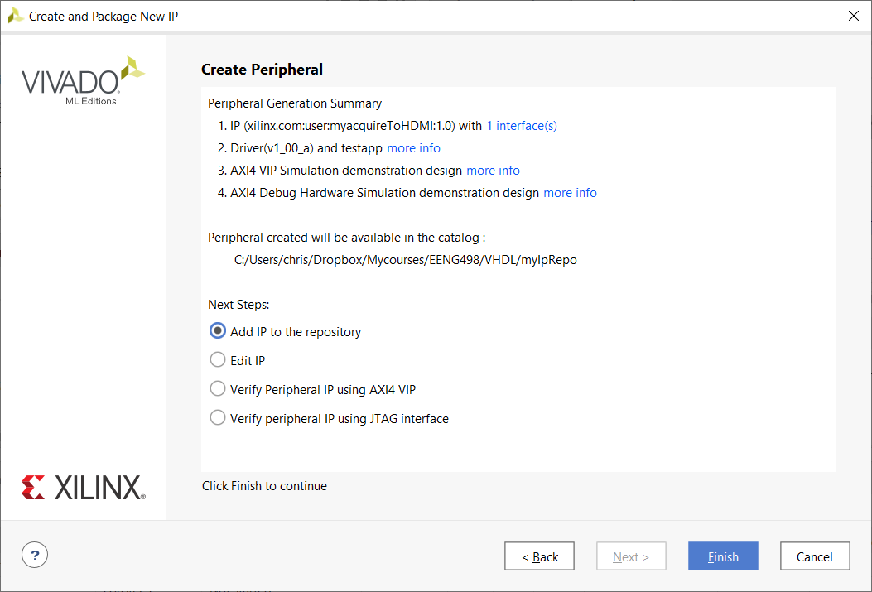

You have just created an empty shell of the new IP. Open the IP Catalog by clicking on the associated link in the Flow Manager on the left side of the screen.

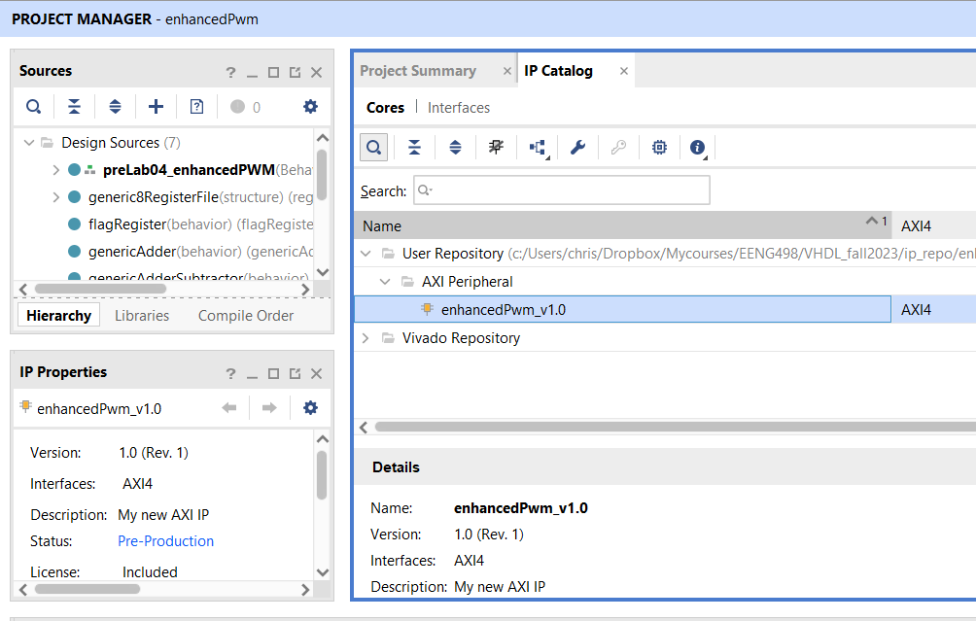
Before moving on, check to make sure that your IP wrapper will be created in VHDL. Do this my right mouse clicking on the enhancedPWM_v1.0 IP element and selecting IP Settings…

In the Settings pop-up, select Project in the Tool Settings area. Make sure that VHDL is selected as the Target Language.
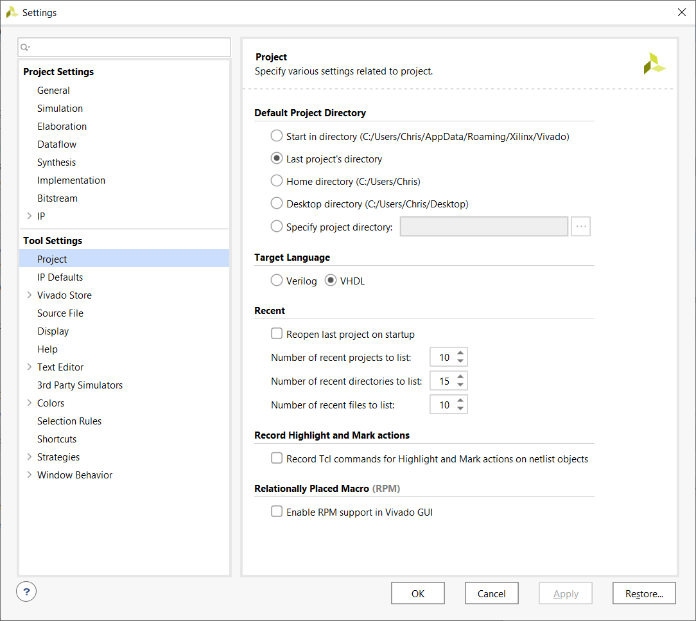

It’s time to fill that shell with your custom logic. To do go to the IP Catalog tab, expand the User Repository -> AXI Peripheral and then right click on “enhancedPwm_ip_v1.0” and select “Edit in IP Packager”
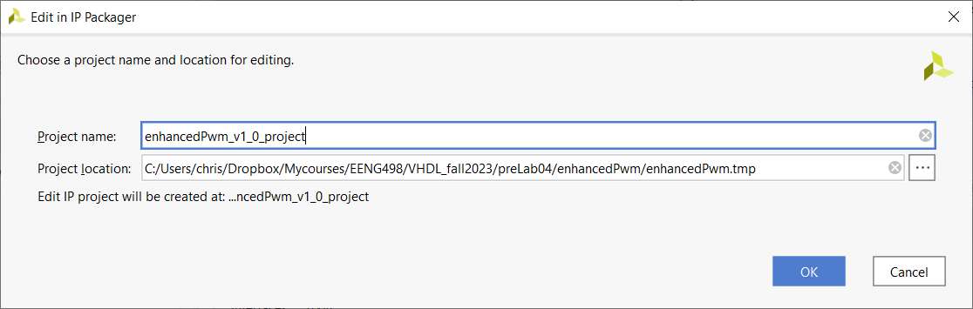
Leave the defaults. Click OK. If you are asked, click OK, to overwrite the previous version. A new invocation of Vivado will launch.
You will now package the enhancedPwm component into a form that will make it compatible to the AXI bus used by the Zynq processor.
Before you start make sure that you have a pair of files in the Design Sources that looks like the following. If you don’t follow the instructions below before proceeding.
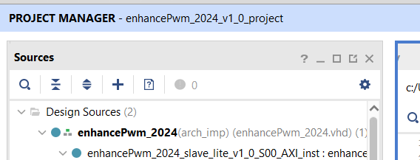
If you have just a single file (just enhancePwm_2024_slave_lite_v1_0_S00_AXI) then close this IP instance of Vivado (File -> Exit), saving if prompted. Then back in the original project, Reopen the enhancedPwm IP by right clicking on it and selecting Edit in IP Packer. Ignore the warning about overwriting the project, you have no edits that will be overwritten.
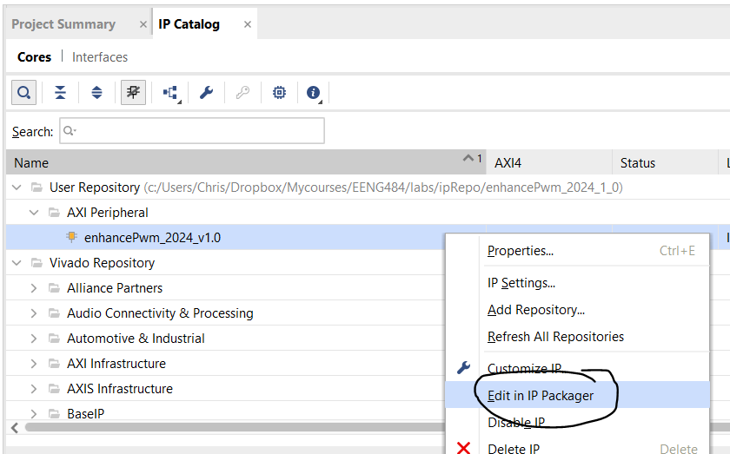

Start by adding enhancedPwm.vhdl to the project. Do this by right clicking on Design Sources and selecting Add Sources…
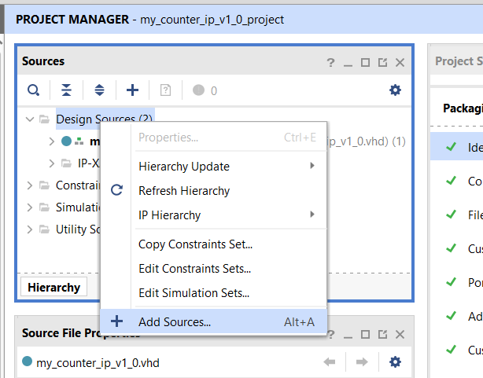
This will launch the Add Sources pop-up.
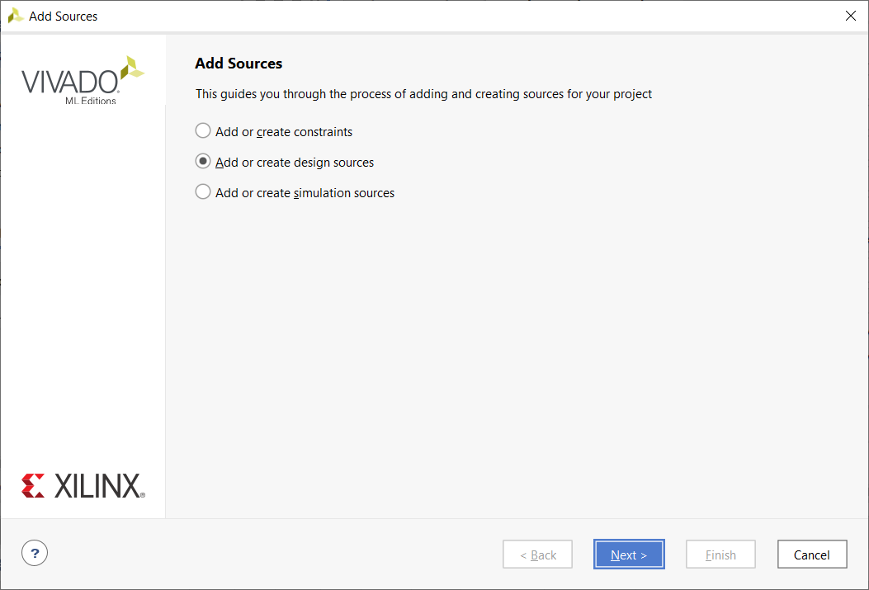
Make sure “Add or create design sources” is selected. Click Next. This will launch the Add or Create Design Sources pop-up.
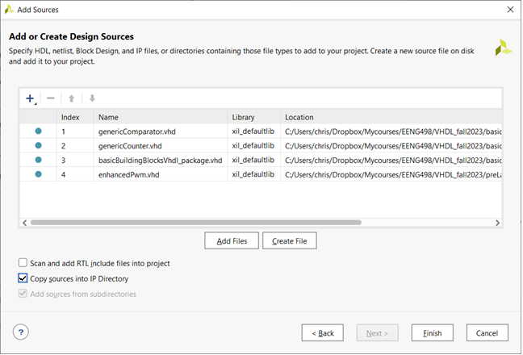
Click Add Files. In the Add Source Files pop-up, navigate to the enhancedPwm, select the file, then click Open. Do the same for the genericCounter, genericCompare and basicBuildingBlocks_package. Make sure to check the “Copy sources into IP Directory. If you do not check this box and then delete this IP unit for any reasons, the linked sources files will also be deleted. Ask me how I know :/ Click Finish.

Edits to: enhancePwm_2024_slave_lite_v1_0_S00_AXI
Start by declaring the enhancedPwm as a component inside enhancePwm_2024_slave_lite_v1_0_S00_AXI.vhd Open the enhancedPwm.vhd file, copy the entity description for the enhancedPwm and then paste it into the enhancePwm_2024_slave_lite_v1_0_S00_AXI.vhd file below the signal declarations and just before the begin statement in the architecture. Then change the entity description into a component description as shown below.
While we are here, include the definition of the pwmCount_int signal that we will use to communicate the pwm count value to the Arm through the AXI interface.
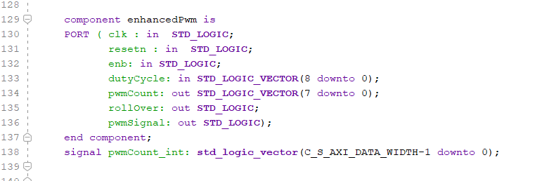
*Please note, your line numbers will be different as this screen shot represent the file when it was completed. You have only just started editing the file.

You now need to instantiate the enhancedPwm component inside the AXI file. Do this at the bottom of the file as follows. In the “add user logic” section of the AXI file, instantiate the enhancedPwm component. The instantiation will:
- Have the ARM set the value of the dutyCycle input through the slv_reg0.
- Send the pwmCount output to a local signal called pwmCount_int and on the ARM through slv_reg1.
- The clk is provided by some external signal, S_AXI_CLK. You will see later that this is the common bus shared by all peripherals. This is important because it keeps your custom hardware synchronized with the ZYNQ processor.
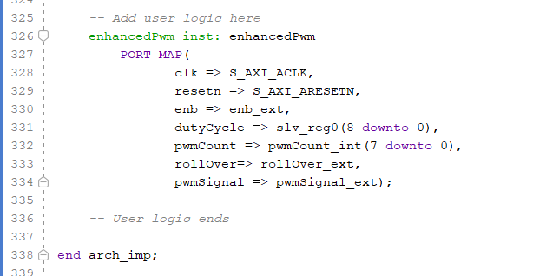
*Please note, your line numbers will be different as this screen shot represent the file when it was completed. You have only just started editing the file.
Line 317: Add the pwmCount_int signal as the value for slv_reg1. This will allow the pwm counter to be read by the Zynq processor when the Zynq processor tries to read slv_reg1.
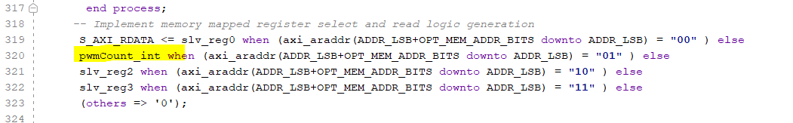

Line 19: Add signals to the port description of enhancePwm_2024_slave_lite_v1_0_S00_AXI. You will need to route these signals outside the Zynq chip. The 1-bits enb_ext will get its value from PL KEY4 and pwmSignal_ext will go to LED4 and rollover_ext will go to LED3.
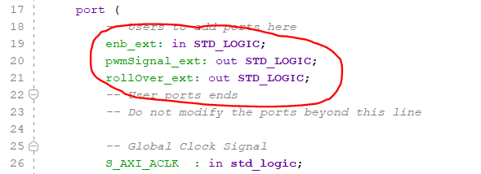

You are done editing enhancePwm_2024_slave_lite_v1_0_S00_AXI. It’s now time to edit this file’s wrapper enhancePwm_2024

Edits to: enhancePwm_2024
You will need to send the enb_ext, pwmSignal_ext and rollover_ext signals outside this module. It’s fairly straightforward.
Line 19: Add signals to port description of enhancePwm_2024
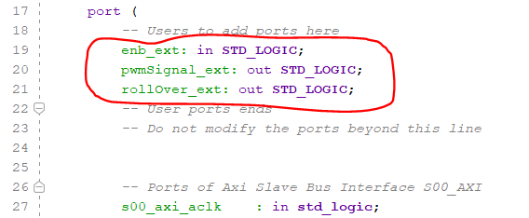

Line 58: Add signals to the instantiation of enhancePwm_2024_slave_lite_v1_0_S00_AXI.
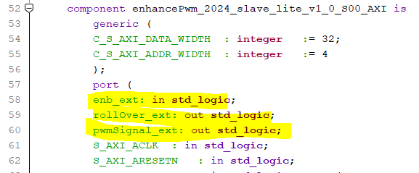

Line 96: Pass through the signal into enhancePwm_2024_slave_lite_v1_0_S00_AXI.
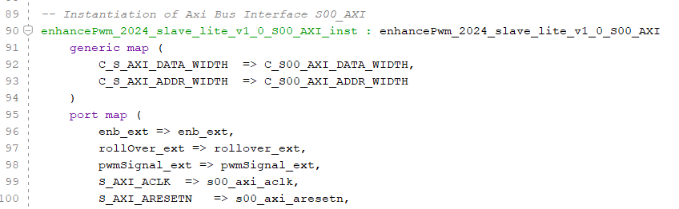

Save the file and check the sources area of the project manager tab once it is done updating. The enhancedPwm component should be part of the hierarchy and there should be no syntax errors.
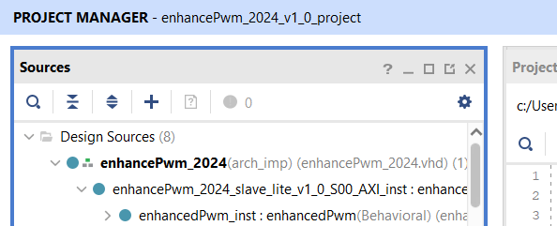
I’d suggest an extra layer of syntax checking by running a behavioral simulation. You should only do this to check for warnings and errors in the Messages area at the bottom of the screen. Only pay attention to syntax-related errors. Ignore things like “Spawn Error”. You can also try to Generate Bitstream to weed out all elaboration errors from vector size mis-matches.
Now it’s time to finish packaging your IP. You will go through the packing steps in the Package IP tab. Each of these is taken in turn below. If you do not see the Package IP tab, click on

Identification – Leave alone
Compatibility – Leave along
File Groups – Click on “Merge changes from File Groups Wizard” This step saves the state of the project. You MUST do this before quitting otherwise you will loose all your work. Ask me how I know :/
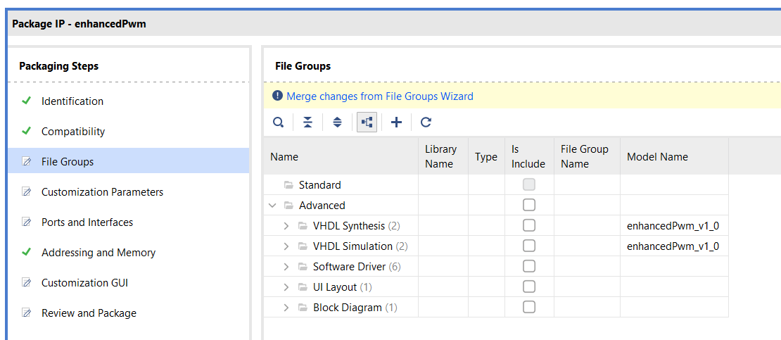

Customization Parameters – Click on “Merge changes from Customization Parameters Wizard”
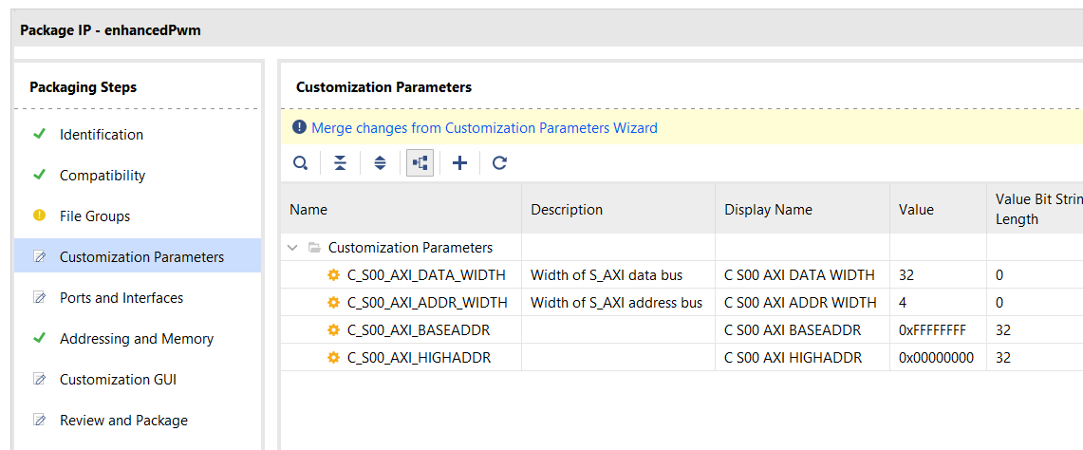

Ports and Interfaces – Check that your enb_ext, pwmSignal_ext and rollover_ext signals have the correct direction and are part of the IP interface.
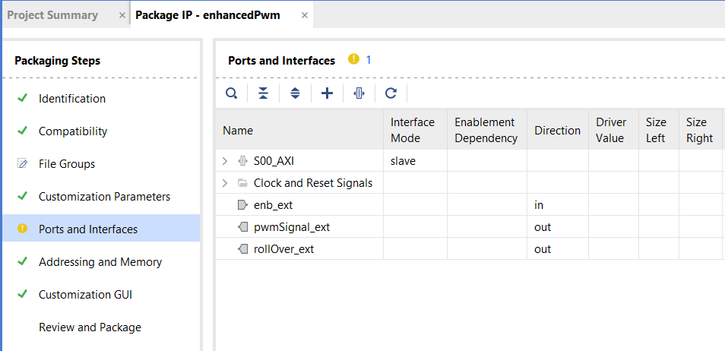

Addressing and Memory – Leave defaults.
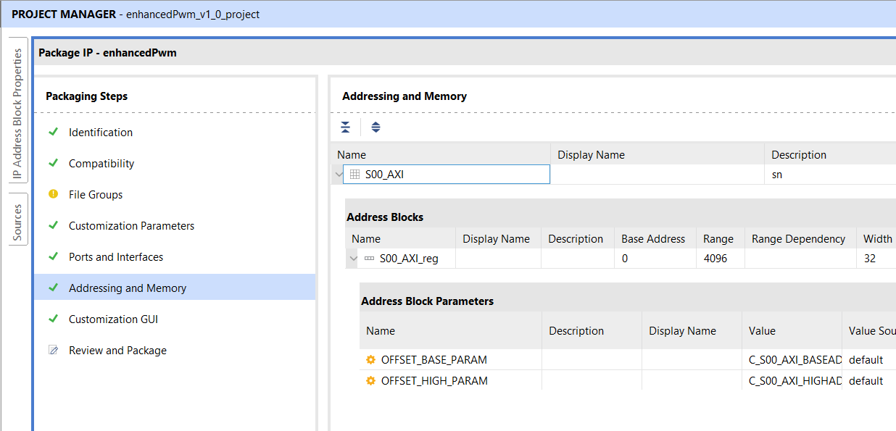

Customizing GUI – Leave defaults. Notice that your enb_ext, pwmSignal_ext and rollover_ext are part of the block diagram. You will need to connect them in a coming step.
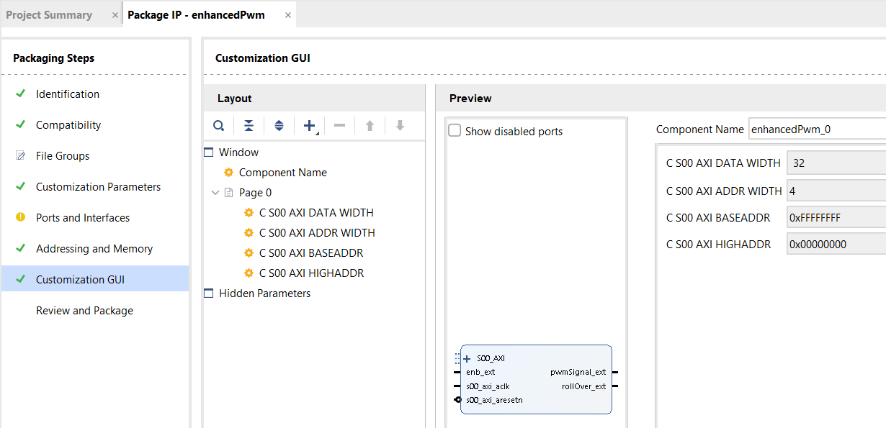

When you get all the errors corrected, you should be safe to complete the process to generate your IP.
Review and Package – Re-Package IP
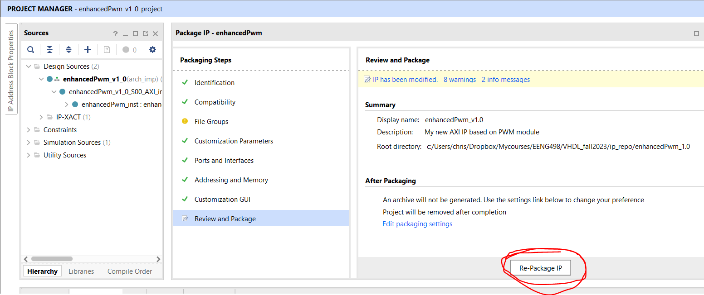

Click the Re-Package IP button and agree to close the project. You can close this project when it’s done.

